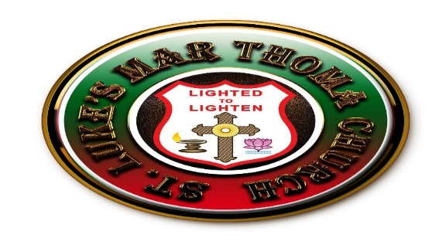
ST LUKE’S MAR THOMA CHURCH
Margate, FL 33063
2017 ANNUAL PICNIC

The St Luke's MTC annual picnic will be held on November 4th, 2017 at 9 am at the Quiet waters park located at 401 S. Powerline Rd., Deerfield Beach, FL 33442
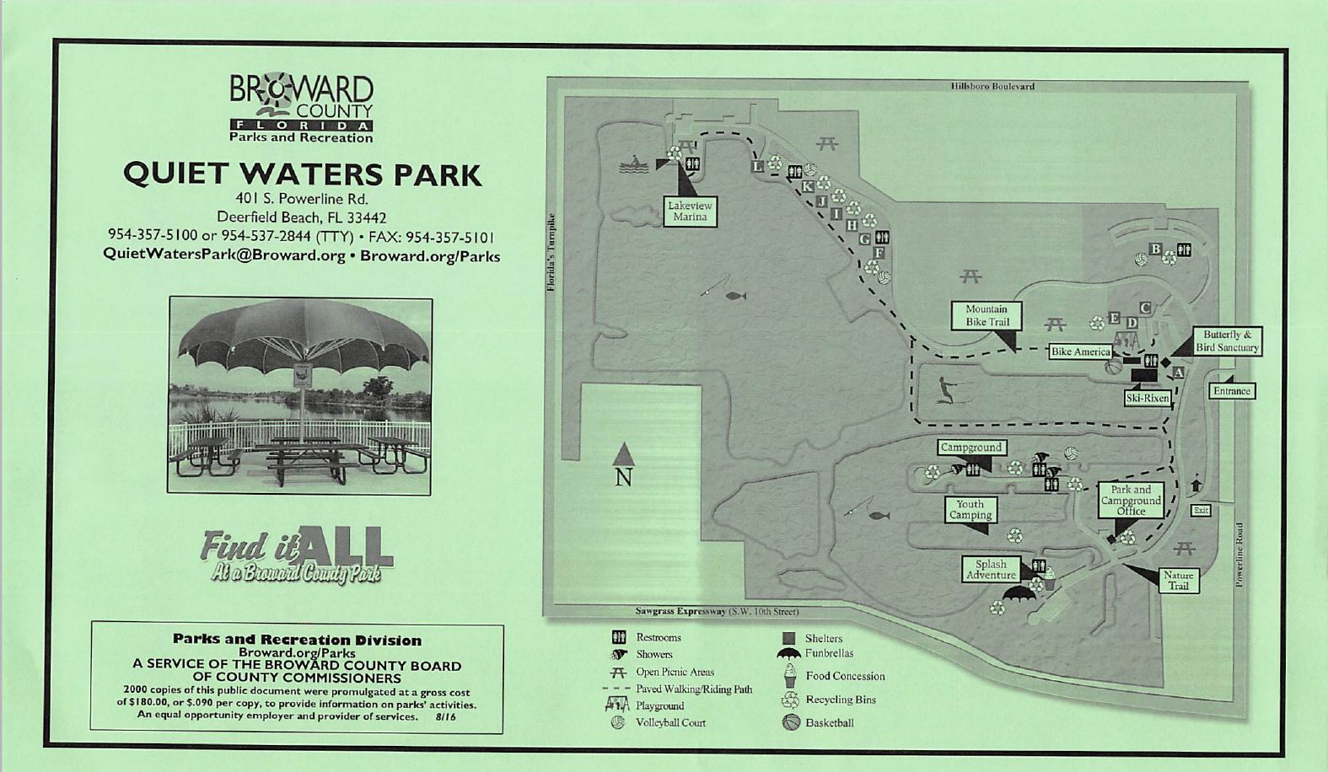
Jacaranda and Kestrel Pavilion
Fun for the family
Food and Barbeque
Games for the whole family

