

Now He who supplies seed to the sower and bread for food will supply and multiply your seed for sowing and increase the harvest of your righteousness

[2 Corinthians 9:10](https://bible.knowing-jesus.com/2-Corinthians/9/10)

[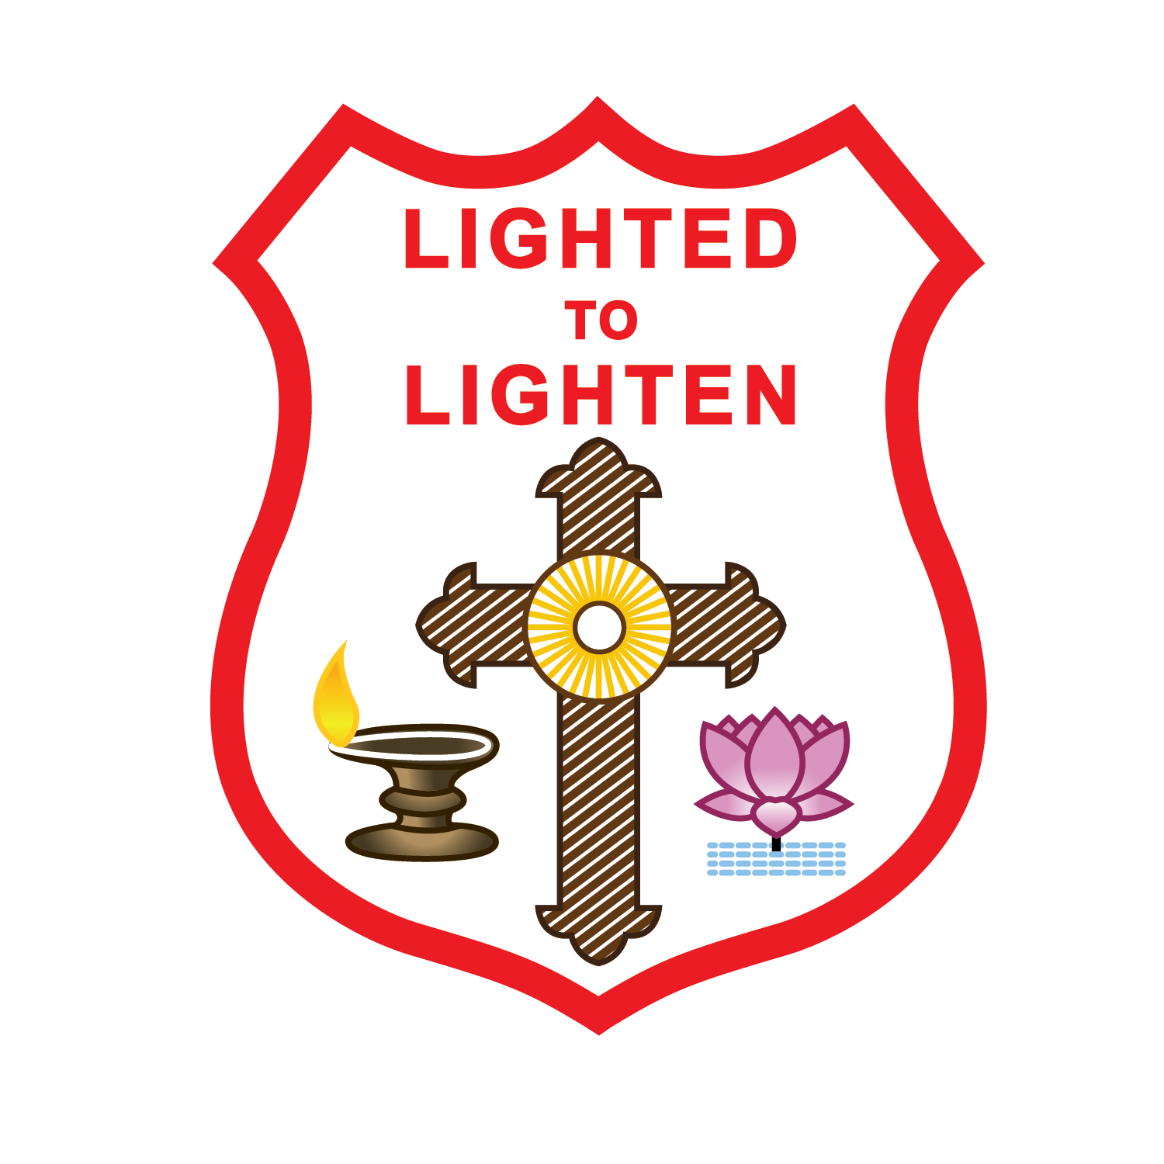](http://www.google.com/url?sa=i&rct=j&q=&esrc=s&source=images&cd=&cad=rja&uact=8&ved=0ahUKEwjYz-7w0K3WAhWEKWMKHS9pD0QQjRwIBw&url=http://ssmtcb.marthoma.in/&psig=AFQjCNGygrWMDss4BqqpQXs6ljkcIvgXCA&ust=1505786203121717)

St. Luke’s Mar Thoma Church, Margate

Harvest Festival 2017

Sunday 24th 2017

**Bake sale Food sale Auction**

Join in and Partake and Pray for the Harvest Festival



